**Missing DASHBOARD:**

1) - number of daily new students. -number of total students

2) - Number of daily new tutor application, -number of total approved tutor

3) - Weekly, monthly and annually company earning

4) – Number of total new question of the day

5) - a school list and related number of questions,

6) - number of new disputes of the day. - total number of open disputes

7) - number of new withdrawals of the day, - total number of unfinished withdrawals

**Withdrawal List** ( only opened show in the list) <http://technovicinity.com/development/tusher/crostutor/public/withdraw-list>

|  |  |  |  |  |  |  |
| --- | --- | --- | --- | --- | --- | --- |
| SL | Created Date | Name | Account | Amount | Paypal | Action |

**Add withdrawal History** (only show the approved one)

|  |  |  |  |  |  |  |
| --- | --- | --- | --- | --- | --- | --- |
| SL | Created Date | Name | Account | Amount | Paypal | Processed Date(Updated Date) |

**Dispute list** (only show the open status) <http://technovicinity.com/development/tusher/crostutor/public/dispute-list>

|  |  |  |  |  |
| --- | --- | --- | --- | --- |
| SL | Created Date | Name | Content(Title) | Action |

**Add Dispute History** (only show closed status)

|  |  |  |  |  |
| --- | --- | --- | --- | --- |
| SL | Created Date | Name | Content(Title) | Status |

**Add tutor application approve screen**

**Tutor detail**

<http://technovicinity.com/development/tusher/crostutor/public/tutor_details/S50R1rYYx7dRMo8ZZEea6evczhi2>

Country code shows the name of the country ( Zach explained in E-mail)

Subject shows in word (not number)

Gender show in word

Please check ‘Photo’ cell,

**School List**

<http://technovicinity.com/development/tusher/crostutor/public/schools>

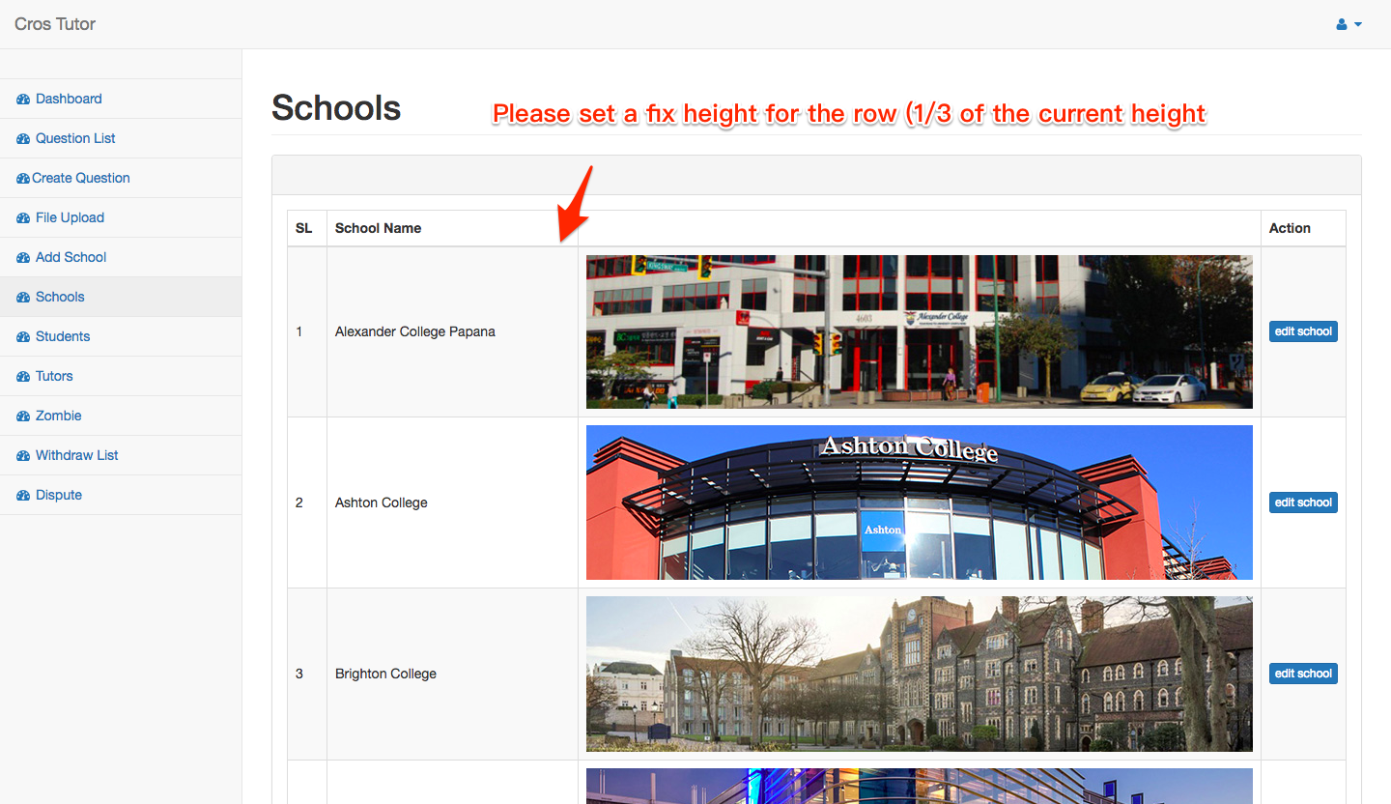

**Editing school is not working:** <http://technovicinity.com/development/tusher/crostutor/public/edit-school/12>

The current information need to prefilled

**Creating Student and Tutor**

<http://technovicinity.com/development/tusher/crostutor/public/create_student>

<http://technovicinity.com/development/tusher/crostutor/public/create_tutor>

Pleas add the “for Admin Use” check box. When the check box checked = which mean this is a **Zombie account** only use for Admin post question and answer.

**Question List**

Please explain your developer the question logic. Regular Question dose not answer by admin

|  |  |  |  |  |  |  |  |
| --- | --- | --- | --- | --- | --- | --- | --- |
| SL | Created Date | Question Content | Subject | Student name | Tutor Name | Committed Date | Answered Date |

**Creating Question**

I think the old design is good.

